**Pressure System**

**Customer requirement**

**Specification:**

**1. System read pressure value from sensor in cabin.**

**2. System inform crew if pressure value above 20 bars by turn on led for 60 secs.**

**Assumptions:**

**1. The pressure sensor never fails.**

**2. The led alarm never fails.**

**Customer requirement diagram:**

**Pressure system need two component, pressure detection and display information.**

**UML: Activity Diagram**

**1. start program**

**2. Read pressure value from sensor**

**3. If pressure value smaller than threshold return to waiting new value and check.**

**4. If pressure value larger than threshold will start alarm by turn on led for 60 sec then return to waiting new value and check.**

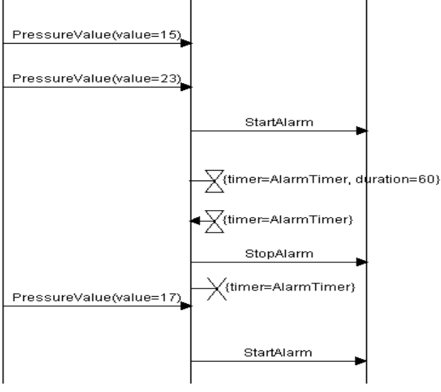**UML: Sequence Diagram**

LED Alarm

Pressure sensorensor

Pressure systemensor

**1. Assume pressure sensor send value to system smaller than threshold system won't happen anything.**

**2. Assume pressure sensor send value to system larger than threshold system will send to led alarm to start alarm for 60 sec then stop alarm.**

**Design: Block Diagram**

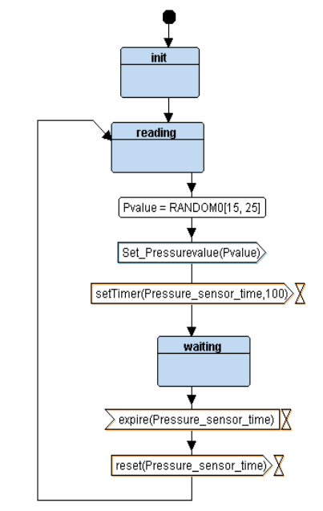**Block: Pressure Sensor Driver**

**1. Start will be initialized pressure sensor driver.**

**2. Go to reading state to get value of pressure.**

**3. Send pressure value to main controller.**

**4. wait for 100 sec to go to reading state again.**

**Block: Main Controller**

**1. Main controllers wait to receive pressure value from pressure sensor**

**2. If pressure value smaller than threshold will be waiting to a new pressure value.**

**3. If pressure value smaller than threshold will be send signal to alarm control to be start alarm then wait to new pressure value.**

**Block: Alarm controller**

**1. First alarm controller will be in state alarm off waiting to receive high pressure detected to go to state alarm on.**

**2. Alarm controller send to led_alarm signal to turn on then set timer for 60 sec then send signal to led_alarm to turn off then return to state alarm off.**

**Block: LED Alarm Driver**

**1. Start will be initialized Led alarm driver.**

**2. Driver waiting to signal to start alarm or to**

**stop alarm.**

**3. If signal start alarm will be go to state alarm on.**

**4. If signal stop alarm will be go to state alarm off.**

**simulate project to show sequence**

1. 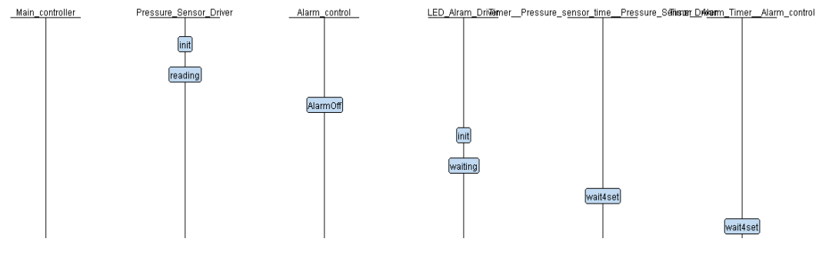**when start program.**

**2.when sensor read value smaller than threshold (20 bar).**

**3.when sensor read value bigger than threshold (20 bar).**

**After implement code will show symbols and sections for each file:**

1. **Symbols for driver of pressure sensor and Led alarm actuator:**

1. **Symbols for Alarm control:**

1. **Symbols for main controller:**

**4- Symbols for pressure detector**

**5. Sections for driver of pressure sensor and Led alarm actuator:**

**6. Sections for Alarm control:**

**7. Sections for main controller:**

**8. Symbols for Pressure system:**

**When run executable on simulation**

1. **When pressure value (19) smaller than threshold (20):**

**2. When pressure value (23) larger than threshold (20):**

